**How to configure a port with an SSL certificate**

Author: Tony Liu

Document History:

|  |  |  |  |
| --- | --- | --- | --- |
| **Doc Version** | **Date** | **Author** | **Comment** |
| 1.0 | 2015/8/20 | Tony Liu | First edition |
|  |  |  |  |
|  |  |  |  |
|  |  |  |  |

1. **Introduction**

This manual provides you step-by-step instructions to configure a port with an SSL certificate, and applies to Windows 7.

NOTE: To configure a port, the tool you use depends on the operating system that is running on your machine.

* 1. **Organization of This Manual**

This user manual is divided into the following sections:

* Introduction
* Import Certificates
* Install SSL Certificate in IIS
* Config Group Policy Settings
* Configure a Port with an SSL Certificate

**Introduction**

This section gives the user a basic idea of this manual.

**Import Certificates**

This section describes how to import CA and SSL certificate with MMC.

**Install SSL Certificate in IIS**

Instructions for Installing an SSL certificate in Microsoft IIS.

**Configure Group Policy Settings**

This section describes how to use the Group Policy Editor to change local policy settings for the computer.

**Configure a Port with an SSL Certificate**

This section describes how to use the Netsh.exe tool to binding an SSL certificate to a port configuration.

1. **Import Certificates**
   1. **Import the CA**

Step 1: Change directory to where the Advantech demo SSL certificate is located. For example: C:\Program Files\Advantech\AdamApax.NET Class Library\Sample Code\WISE\Win32\PrivateServer\SSL Cert



Step 2: Start a Command Prompt as an Administrator, type mmc, and then press ENTER, This command starts MMC (Microsoft Management Console).

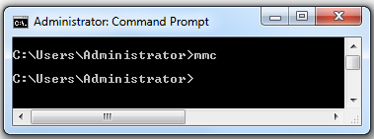

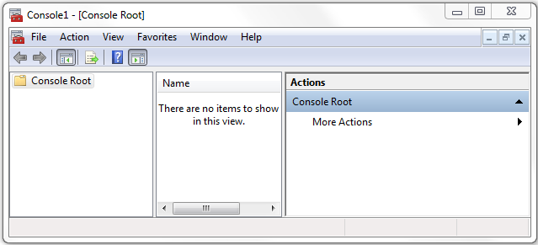

Step 3: Use MMC GUI to import CA (For example: WISE-CA.cer) in Trusted Authority store.

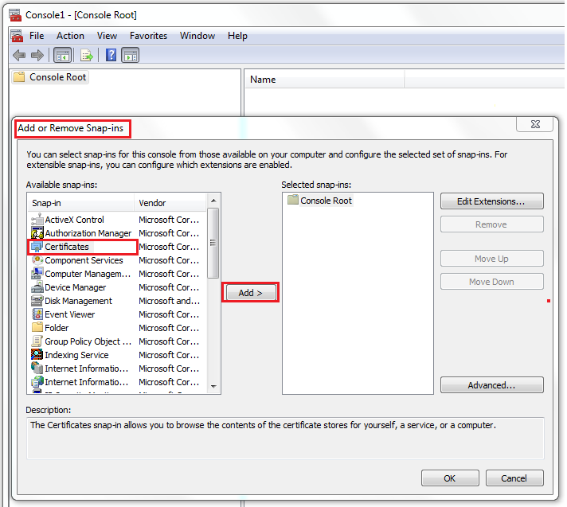

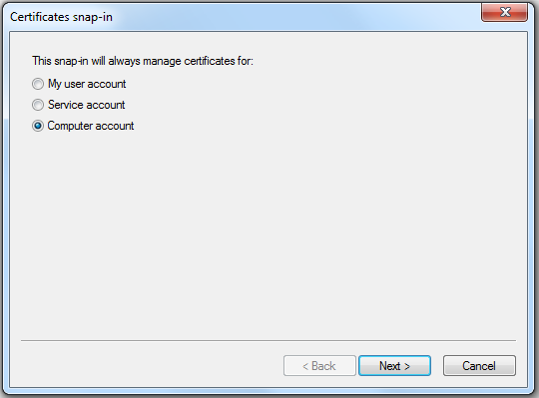

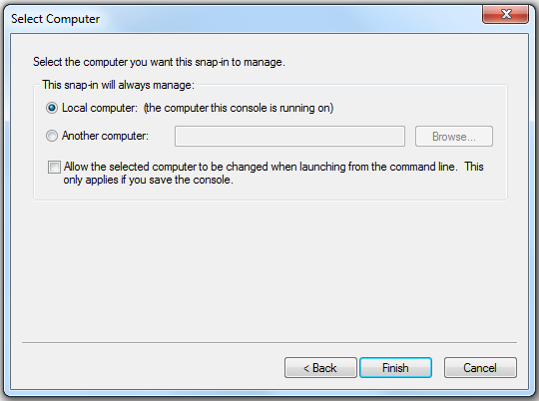

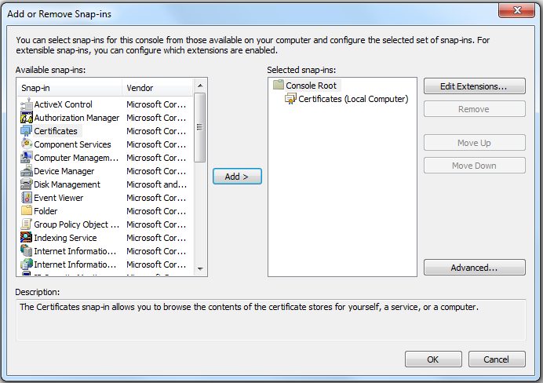

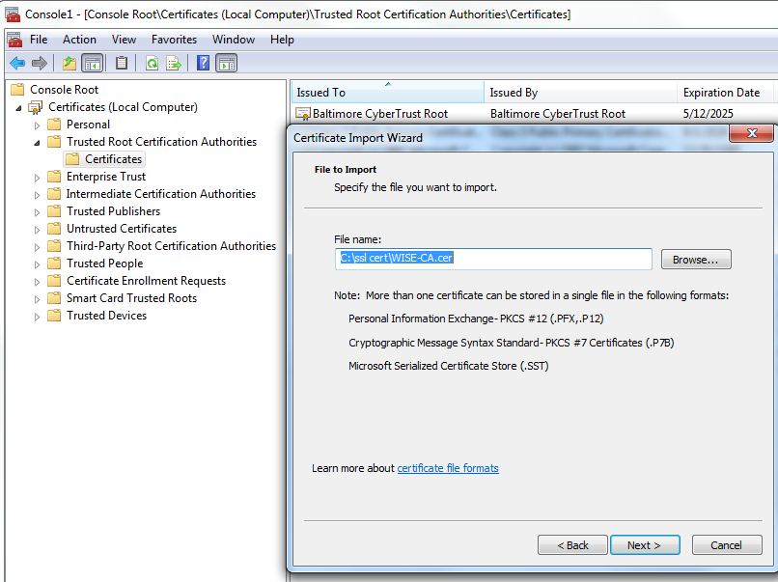

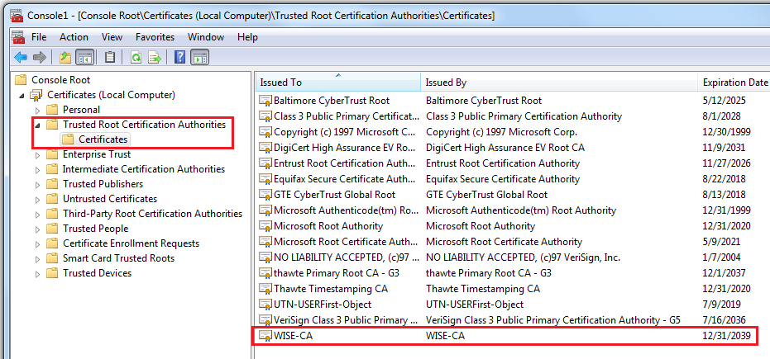

* 1. **Import the SSL cert**

Step 1: Use MMC GUI to import SSL cert (For example: WISE-Site.cer) in Personal store.

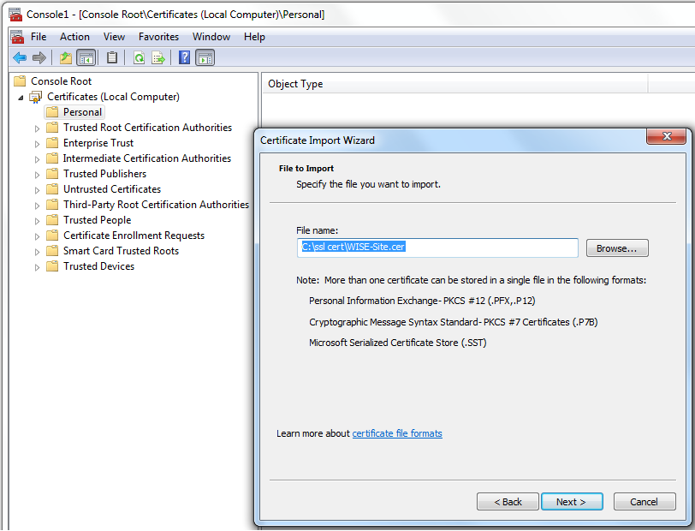

Step 2: Click the Details tab, scroll to the bottom of the fields to see the thumbprint field, Configuration steps later require the fingerprint of the SSL certificate you jus imported.

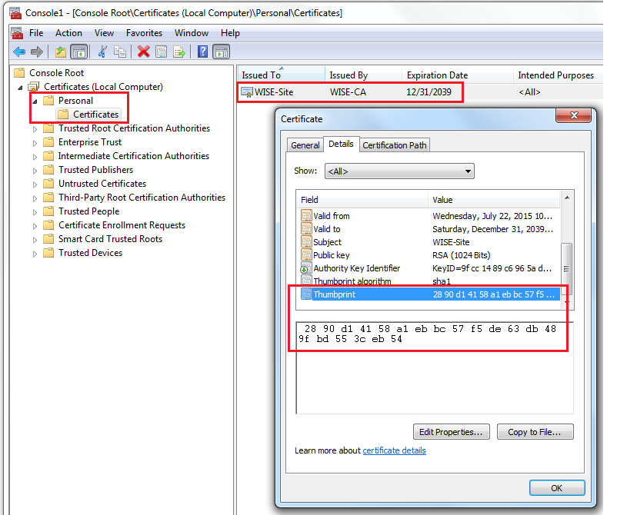

1. **­Install SSL Certificate in IIS**

Step 1: Click on the Start menu, go to Administrative Tools, and click on Internet Information Services (IIS) Manager.

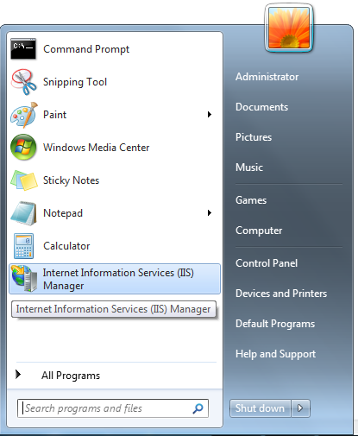

Step 2: Click on the name of the server in the Connections column on the left. Double-click on Server Certificates.

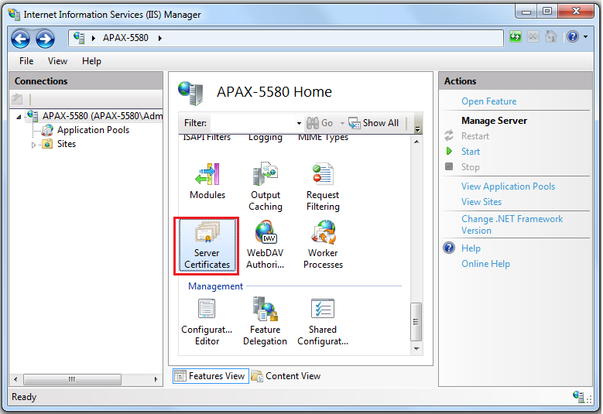

Step 3: In the Actions column on the right, click on “Import…”, import certificate file (For example: WISE-Site.pfx).

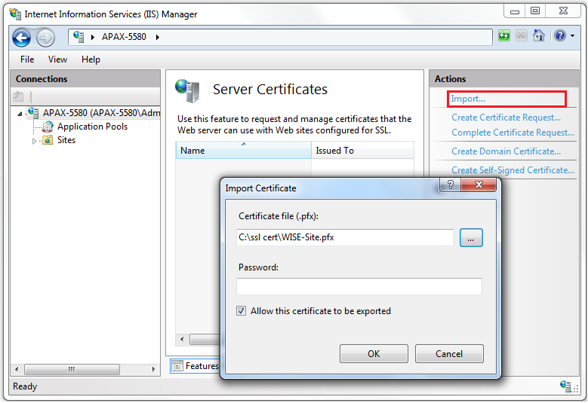

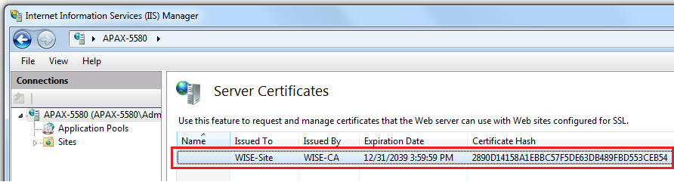

1. **Configure Group Policy Settings**

Step 1: Open your group policy editor by entering gpedit.msc at a command prompt (run as administrator).

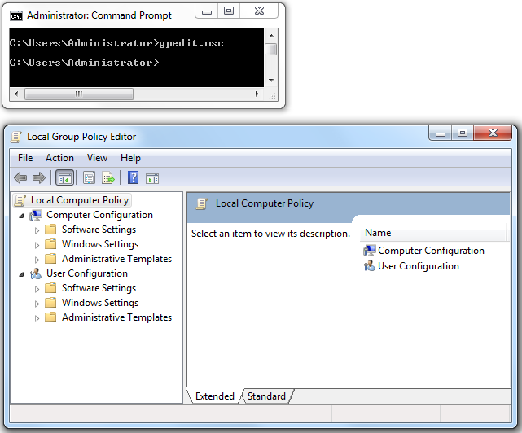

Step 2: Choose Computer Configuration | Administrative Templates | Network | SSL Configuration Settings. There’s only one item here : SSL Cipher Suite Order. Open it.

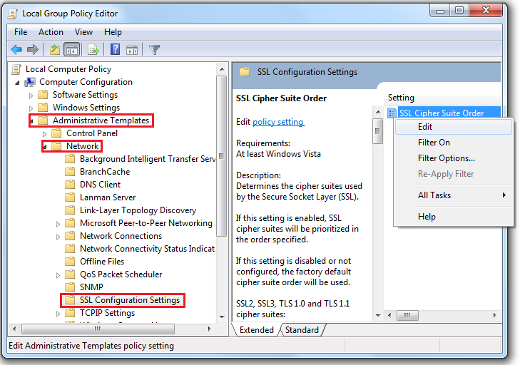

Step 3: Select “Enabled” option, and you’ll need to reboot your computer.

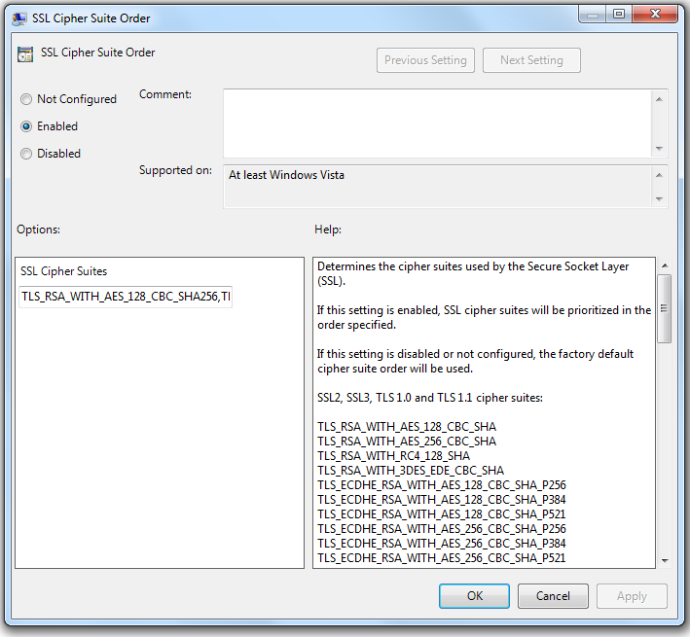

1. **Configure a Port with an SSL Certificate**

Step 1: Retrieve the “GUID” value stored in the Assembly Information in the project properties (For example: Dot NET WISE Private Server sample code).

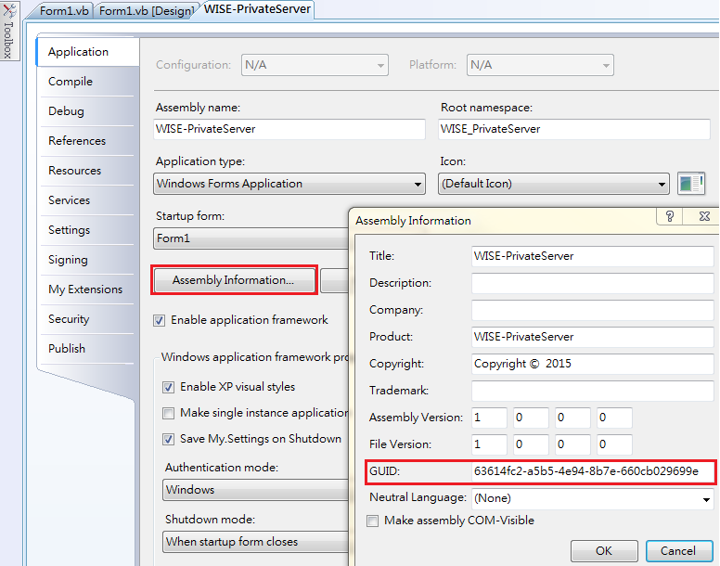

Step 2: Use the Netsh.exe tool to bind a SSL certificate to an endpoint (IP:Port), as shown in the following example.

* The “certhash” parameter specifies the thumbprint of the certificate.
* The “ipport” parameter specifies the IP address and port number.
* The “appid” parameter is a GUID that can be used to identify the owning application.

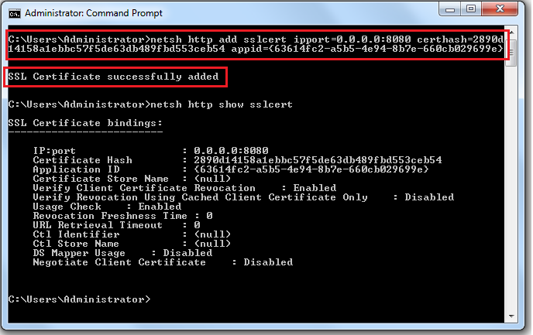

Step 3: Now you should be able to go ahead and run the tests (For example: Dot NET WISE Private Server sample code), and see the run results.

